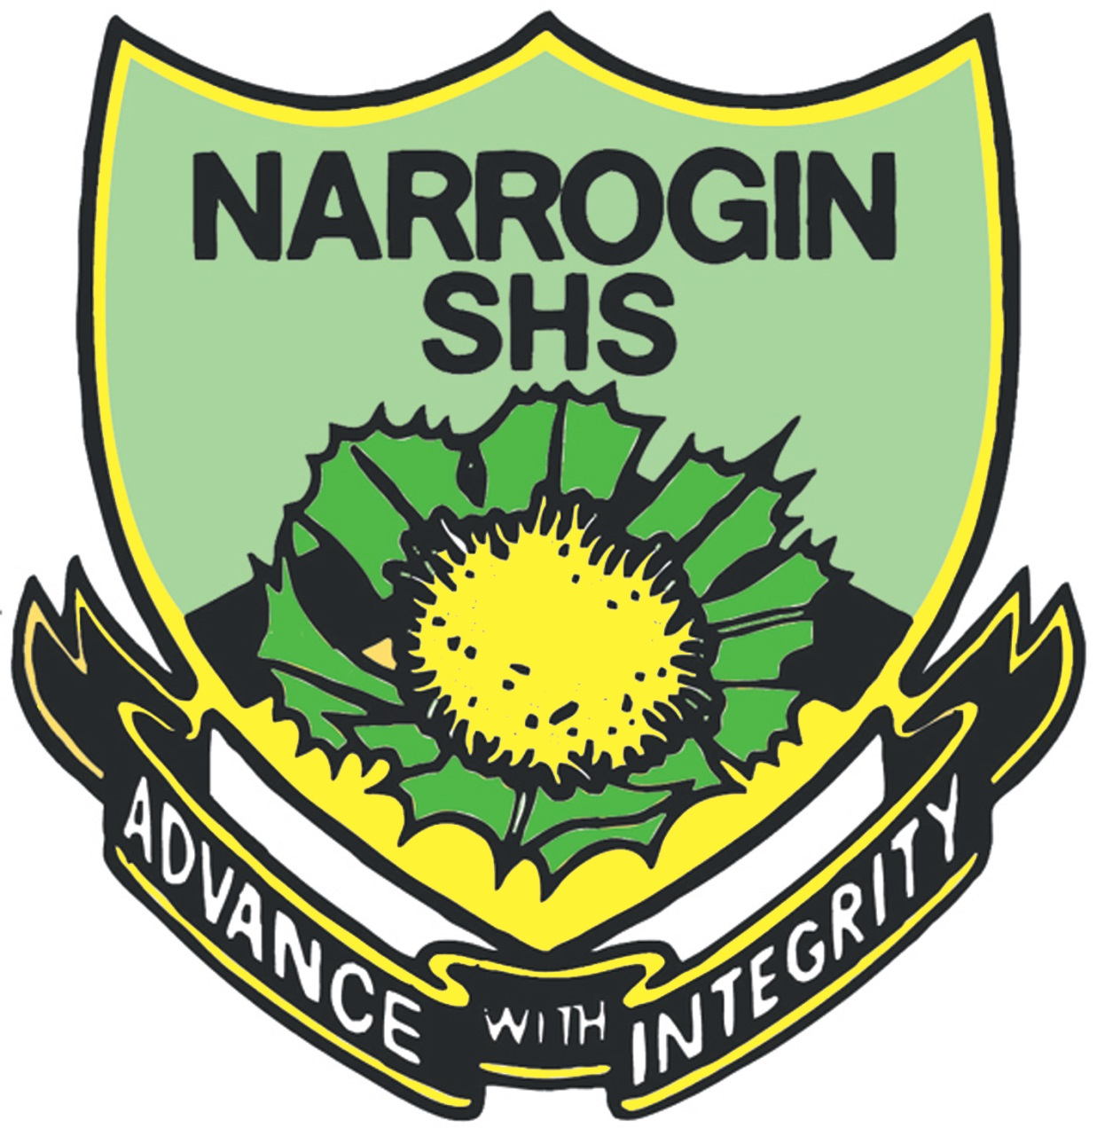

12 FOUNDATION ENGLISH

2018 COURSE OUTLINE

Semester 1 & 2
Week | Key teaching points | Syllabus content | Assessment tasks
Term 4  Weeks 5-6  Term 1  Weeks 1-4 | Insights  Students explore a range of social issues from several perspectives across language modes and types of literary, every day and workplace texts. They consider how certain perspectives and values are presented in texts to influence audiences.  Examples of social issues:  - Abuse and violence  - Bullying  - Discrimination (race, gender, age, religion, sexuality, etc.  - Drug and alcohol abuse  - Mental health  - Obesity  - Sexual violence  - Sustainability  - Smoking | - Identify facts, opinions, supporting evidence and bias  - Distinguish different perspectives about the main ideas in texts  - Consider how different perspectives and values are presented in texts  - Gather different viewpoints  - Select text structures, language features and visual techniques to communicate and present ideas and information  - Speak clearly and coherently about ideas, opinions and personal experiences in a range of oral contexts  - Plan and carry out projects in small groups, sharing tasks and responsibilities  - Use appropriate vocabulary, spelling and sentence structures  - Understand the way attitudes and values are presented | Task 1A: 5%  Set: T4 W5  Due: T1 W3  Writing  (In class and at home)  Maintain a reflective journal and respond to a series of focus questions across your reading and viewing.  Task 1B: 10%  Set: T1 W3  Due: T1 W4  Oral  (In class)  Group presentation to the class which discusses text construction and identifies the attitudes and values expressed about one social issue facing young. The aim of the presentation is to engage, inform and educate.
Weeks  5-7 | Comic or not?  Students read and view selected comic books/picture books and/or graphic novels to consider how changing purposes, contexts and audiences have influenced the world views and values these texts have conveyed over time. | - Apply different reading strategies  - Explore attitudes, text structures and language features to understand a text’s meaning and purpose  - Use information for specific purposes and contexts  - Examine relationships between context, purpose and audience in different language modes and types of texts, and their impact on meaning  - Explaining shifts in tone and perspectives and identifying the effect of language choices on an audience | Task 2: 10%  Set: T1 W5  Due: T1W7  Writing  In class  Short answer responses to questions based on studied texts.
Weeks  8-11 | Unreal TV  Students explore the extent to which the world is depicted in a realistic way in a selected mainstream television series. Students focus on how different perspectives and values are presented in one series and how these views are communicated, presenting their findings in a comprehensive feature article.  Some areas to consider:  Is mainstream drama too ‘Americanised?’  Do the police and lawyers always get the bad guys/girls in police/law drama  Are nerds misrepresented in The Big Bang Theory? | - Select text structures, language features and visual techniques to communicate and present ideas and information  - Categorise and integrate ideas and evidence about specific issues, Employ ethical research practices such as acknowledging sources, and avoiding plagiarism and collusion, Use strategies for planning, drafting, revising, editing and proofreading, appropriate referencing  - Learn how to communicate logically, persuasively and imaginatively for different purposes. | Task 3: 10%  Set: T1 W8  Due: T2 W11  Reading  In class and at home  Create a review of a television series presents the world in a particular way.
Term 2  Weeks  1-3 | Not fair  Students work in groups to research a workplace issue affecting young members of the workforce for a panel discussion which explores this issue from a range of viewpoints and perspectives. Some issues to consider may be equal work for equal pay, discrimination, bullying in the workplace or workplace health and safety issues. | - Recognise when to work with others and when to work independently  - Use the language of negotiation, problem solving and conflict resolution  - Categorise and integrate ideas and evidence about specific issues  - Express a logical point of view about an idea, issue or event  - Determine the relevance of source material to the context and topic  - Listening actively; being prepared to assert personal views | Task 4: 15%  Externally set task  Task 5: 10%  Set: T2 W1  Due: T2 W3  Oral  Oral and written in class and at home  Panel discussion exploring at least one workplace issue from a range of viewpoints and perspectives. Each group to create an info graphic which summarises its findings for distribution to the class. Panellists are expected to be aware of workplace rights and obligations.
Weeks  4-8 | Australia in conflict  Students read and view a wide range of texts considering alternative views and perspectives on Australian service men and women’s involvement in twentieth century conflicts. Students examine how some perspectives are privileged while others are marginalised.  Some issue to consider across these conflicts may be Breaker Morant in the Boer War, indigenous Australians service men and women’s treatment in WW2, conscription in the Vietnam War, Australian attitudes to returned soldiers from Vietnam or attitudes towards Australia’s involvement in the Afghanistan conflict. | - Consider how some perspectives are privileged while others are marginalised or silenced  - Consider how attitudes and assumptions are presented in texts  - Evaluate the evidence upon which different views are based  - Investigate and synthesise ideas and collate information from a range of source | Task 6: 10%  Set: T2 W4  Due: T2 W8  Reading  In class  Explore how some perspectives are privileged while others are marginalised or silenced in one reading and/or viewing text you have studied this year.
Term 3  Weeks  1-3 | Hope in dark times  Students read and view a range of dystopian and post-apocalyptic texts to consider the perspectives offered and examine how written and visual language is used to appeal to the beliefs, attitudes and values of an audience. | - Explain how texts use language to appeal to the beliefs, attitudes and values of an audience  - Discuss the way ideas and information are presented in texts  - Use appropriate vocabulary, spelling and sentence structures  - Consider how attitudes and assumptions are presented in texts | Task 7: 10%  Set: T3 W1  Due: T3 W3  Writing  In class and at home  Write a diary entry on a dystopian/post-apocalyptic text.
Weeks  4-6 | Hip-hopping mad  Students explore an issue in popular music culture and examine the role of social media in communicating perspectives and shaping viewpoints.  Issues may include:  - Iggy Azalea/Azealia, Banks/Eminem lyrics conflicts  - The cultural appropriation issue, The treatment of females as objects | - Analyse issues and ideas in texts and explain perspectives and implications  - Discuss the way ideas and information are presented I texts  - Create oral texts that communicate ideas and perspectives | Task 8: 10%  Set: T3 W4  Due: T3 W6  Reading  Oral  Individually or in pairs, research a range of different viewpoints on a controversial issue in popular music culture
Weeks  7-10 | Your West Weekend  Students work cooperatively and collaboratively to create a magazine similar in format to West Weekend, targeting a specified audience to communicate a range of relevant information using different types of texts (see Glossary) and including original photographs and advertising. Students have the opportunity to create a wide range of text types and forms in a range of language modes.  A focus of this activity is fostering effective group work practices. The project encourages individual initiative, independence and provides opportunities for students to learn from each other. | - Consider how attitudes and assumptions are presented in texts, including the use of media, types of texts, text structures and language features  - Employ ethical research practices such as acknowledging sources and avoiding plagiarism and collusion  - Integrate text structures, language features and visual techniques to engage and persuade audiences  - Use editing processes and appropriate referencing  - Use and adapt text structures and language features to communicate ideas in a range of media  - Recognise when to work with others and when to work independently  - Use the language of negotiation, problem solving and conflict resolution | Task 9: 10%  Set: T3 W7  Due: T3 W10  Writing  In class and at home  Working cooperatively and collaboratively in groups, students create and publish a magazine similar to the West Weekend, targeting a specified audience. Communicate to this audience a range of relevant information using different types of texts and including original photographs and advertising.
Term 4  Weeks 1-2 | Work Readiness  Students work collaboratively to prepare for work place interviews | - Develop questions and answers for work place interviews  - Discuss the way ideas and information are presented in job interviews  - Create oral texts that communicate ideas and perspectives for job interviews | No Assessment

